**Introduction**

**What is a Project?**

-A project is a temporary endeavor undertaken to create a unique product, service, or result.

Projects create unique products or services, or outcomes known as deliverables

**Projects can involve**

* + - A single individual or a group
    - A single organizational unit or multiple units from multiple organizations
* Projects are temporary in nature and have a definite beginning and ending date.​
* A project is a temporary endeavor of inter-related activities undertaken to create a unique product, service, or result​
* A project ends when the objectives are achieved, or it is terminated by the sponsor ​
* Projects create business value for the organization and initiate change

**Projects drive change: Organizations move from current state to future state by implementing projects. Time is used up and business value is achieved.**

**What are Operations?**

* Operations are ongoing activities in any organization​
* Daily activities of a business​
* Repetitive tasks ​
* Using standard operational procedures​

**What is Project Management?**

Project management is the application of knowledge, skills, tools, and techniques to project activities to meet the project requirements. Project management is accomplished through the appropriate application and integration of the project management processes identified for the project”.

* **Effective project management helps in:**
  + Meeting business objectives
  + Satisfying stakeholders expectations
  + Optimizing the use of resources
  + Managing change
  + Responding to risks in a timely manner
* **Poor project management can lead to:**
  + Missing deadlines
  + Poor quality of project
  + Cost overruns
  + Scope creep
  + Unsatisfied stakeholders
  + 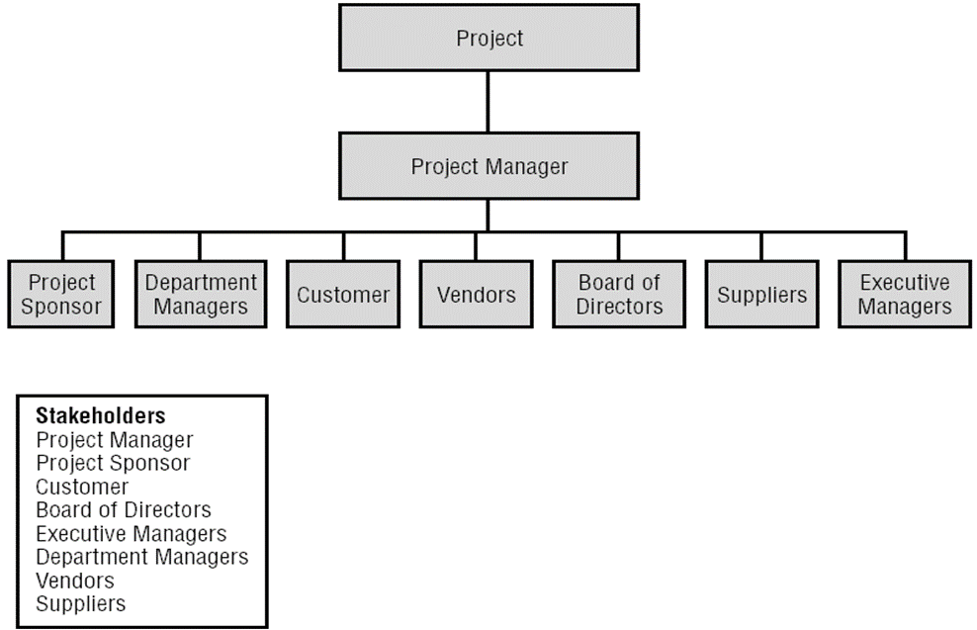Project failure
    - **Project Stakeholders:** Any individual or party that has interest in the project.

**The Triple Constraints:**

**1.Scope : has specific objectives**

**2.Schedule : has a clear start and end date**

**3.Resources : has limited resources**

- Project managers must balance the three constraints to complete a project successfully.

**Project Success Measures**

* Project must have clearly stated project objectives that are measurable
* Some questions that the key stakeholders and the project manager should address are
  + What does success look like for this project?
  + How will success be measured?
  + What factors may impact success?
* The answer to these questions should be documented and agreed upon by the key stakeholders and the project manager
* Project success may include additional criteria linked to the organizational strategy and to the delivery of business results

**Project, Programs, and Portfolios:**

-A project is a temporary endeavor undertaken to create a unique product, service, or result.

-A program is a group of related projects, subsidiary programs, and program activities that are managed in a coordinated manner to obtain benefits not available from managing them individually.

* “A portfolio is a collection of projects, programs, and operations managed as a group to achieve strategic objectives.” Excerpt from Project Management Institute, *A Guide to the Project Management Body of Knowledge, (PMBOK® Guide) – Sixth Edition*, Project Management Institute Inc., 2017, Page 52.
  + Program and project management focus on doing them the right way.
  + Portfolio management is about doing the right programs and projects to meet the strategic goals.

**Project Management Processes:**

-A project life cycle is the series of phases that a project passes through from its start to its completion.

* A project life cycle is managed by executing a series of project management processes.
* Every project management process produce one or more outputs, from one or more inputs, using appropriate project management tools and techniques.

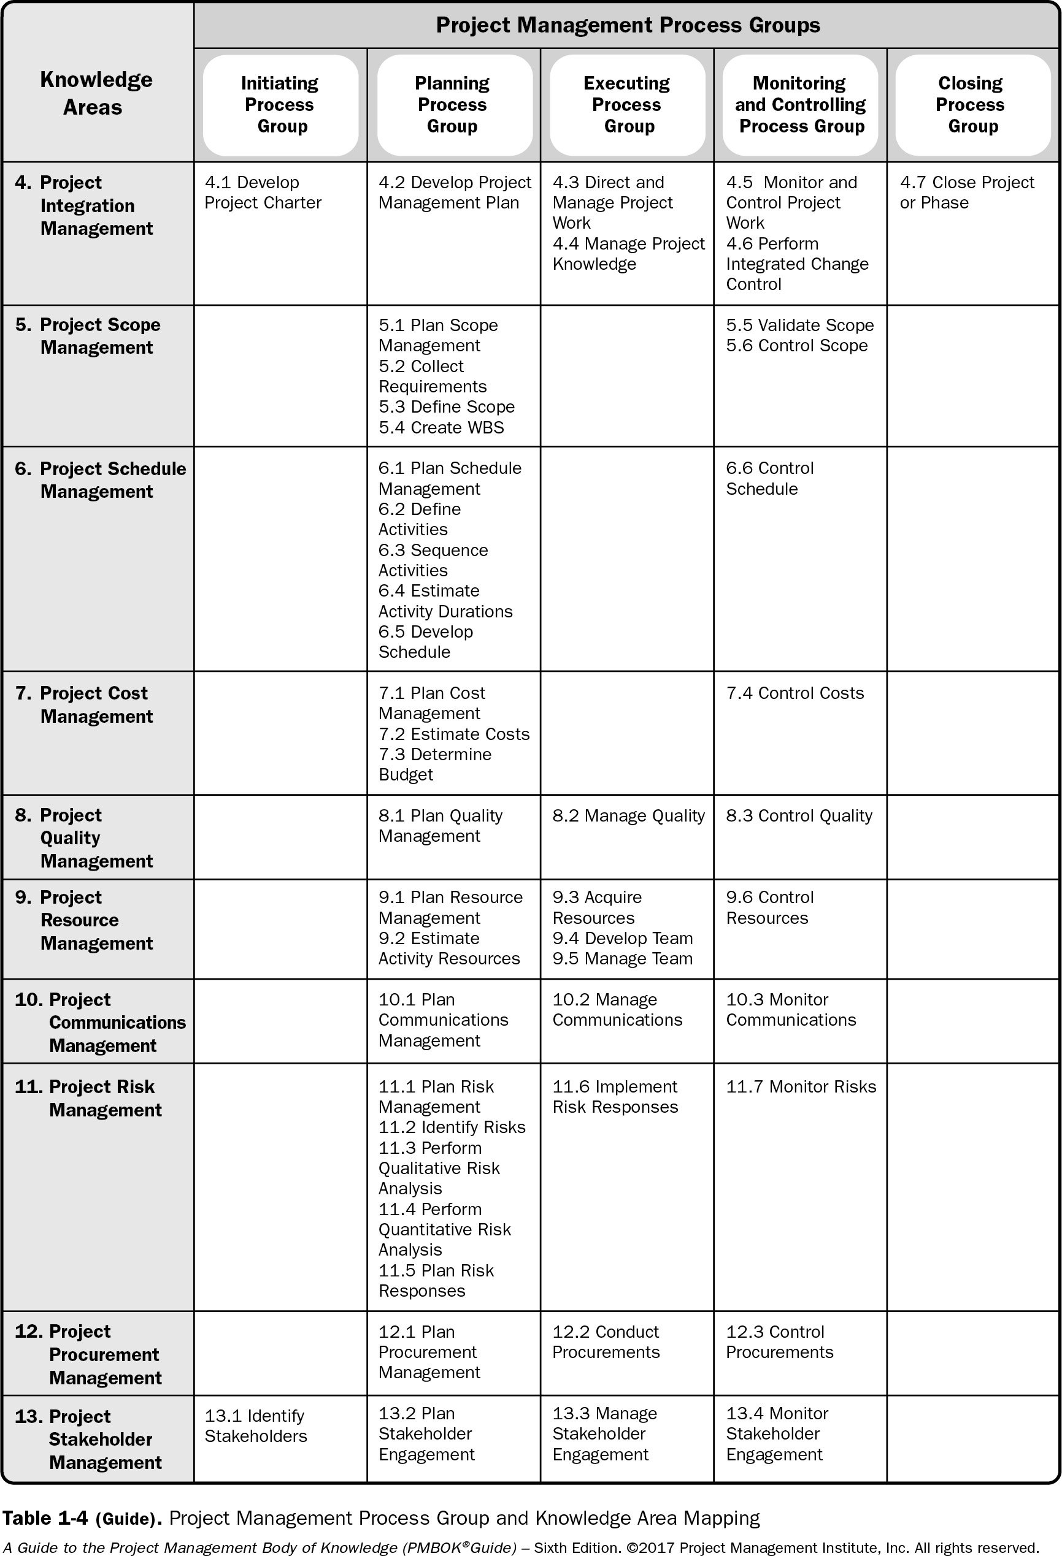

Foundation Elements: Organizational Systems

**Projects operate within organizations.**

* The project manager needs to understand where the authority reside in the organization so that he/she operates effectively.
* Factors that affect this include:
  + Management elements
  + Governance frameworks, and
  + Organizational types
* **Management Elements**
* The key functions or principles of management include:
* Authority given to perform work
* Division of work using specialized skills
* Responsibility to perform work
* Optimized use of resources
* Clear communication channels
* Fair and equal treatment of people in the workplace.

**Organizational Governance Frameworks**

* Governance framework refers to the structural arrangements at all levels of the organization.
* It defines authority and influences how objectives of the organization are set and how performance is optimized
* 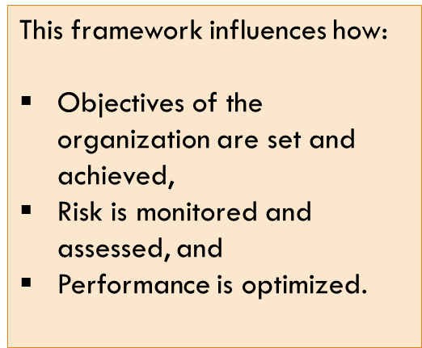It includes:
* people,
* roles,
* structures,
* policies,
* Procedures,
* Relationships, and
* Others

**GOVERNANCE OF PORTFOLIOS, PROGRAMS, AND PROJECTS**

* Project governance refers to the framework, functions, and processes that guide project management activities in order to create a unique product, service, or result to meet organizational, strategic, and operational goals.
* There is no one governance framework that is effective in all organizations.
* A governance framework should be tailored to the organizational culture, types of projects, and the needs of the organization in order to be effective.

**PROJECT MANAGEMENT OFFICE**

* A primary function of a PMO is to support project managers in a variety of ways, which may include but are not limited to:
* Managing shared resources across all projects administered by the PMO;
* Identifying and developing project management methodology, best practices, and standards;
* Coaching, mentoring, training, and oversight;
* Monitoring compliance with project management standards, policies, procedures, and templates by means of project audits;
* Developing and managing project policies, procedures, templates, and other shared documentation (organizational process assets); and
* Coordinating communication across projects.
* A project management office (PMO) is an organizational structure that standardizes the project-related governance processes and facilitates the sharing of resources, methodologies, tools, and techniques. The responsibilities of a PMO can range from providing project management support functions to the direct management of one or more projects.
* There are several types of PMOs in organizations. Each type varies in the degree of control and influence it has on projects within the organization, such as:
  + **Supportive.** Supportive PMOs provide a consultative role to projects by supplying templates, best practices, training, access to information, and lessons learned from other projects. This type of PMO serves as a project repository. The degree of control provided by the PMO is low.
  + **Controlling.** Controlling PMOs provide support and require compliance through various means. The degree of control provided by the PMO is moderate. Compliance may involve:
* Adoption of project management frameworks or methodologies;
* Use of specific templates, forms, and tools; and
* Conformance to governance frameworks.
* **Directive.** Directive PMOs take control of the projects by directly managing the projects. Project managers are assigned by and report to the PMO. The degree of control provided by the PMO is high.

Functional Organizations

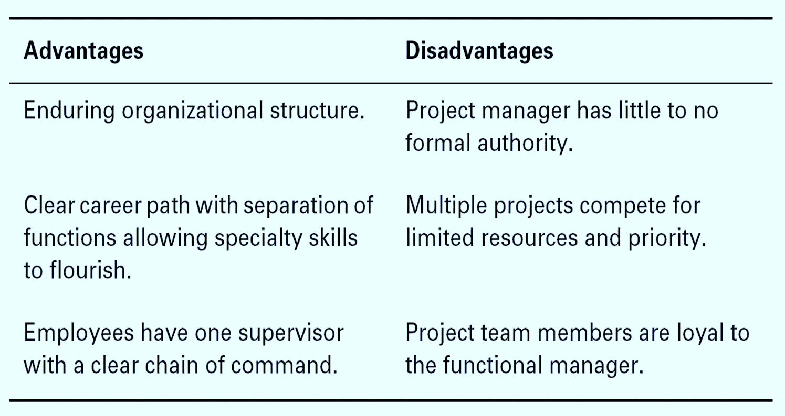

**Comparing Matrix Structures**

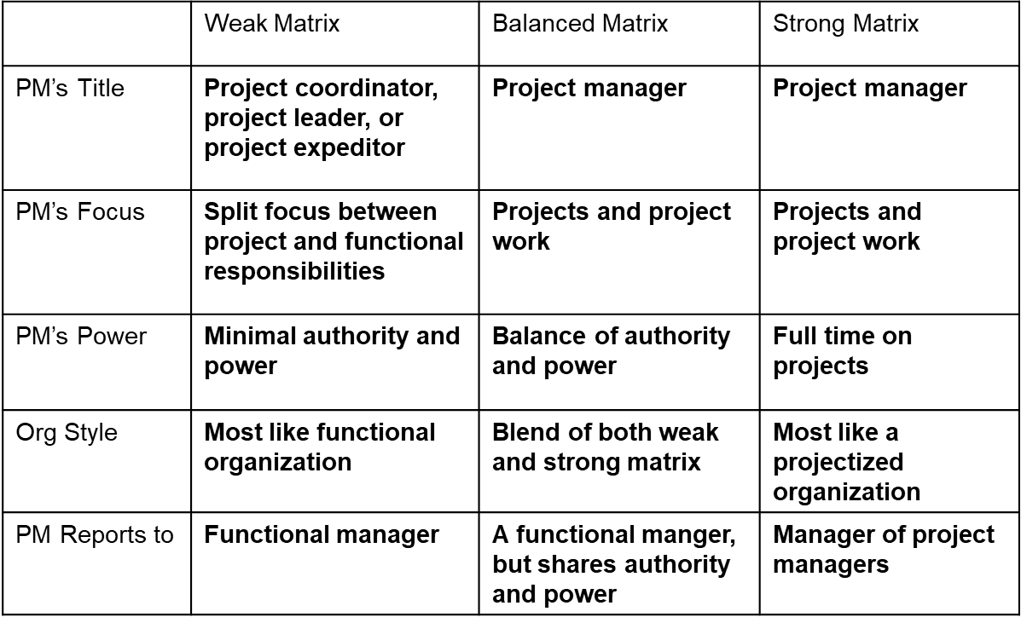**The Difference between Leadership and Management**

**Management:** Accomplish near-term goals - Directs using positional power – Administrate -Accepts status quo or the current state- Do things right.

**Leadership:** Set long-term vision/ Guides and influences /Innovate /Challenge status quo or the current state/Do the right thing.

* **The project manager** is responsible about performing **integration** on the project processes
* Integration is an important and critical skill for project managers, integration is done in two ways
  1. Working with the project sponsor to ensure that they meet requirements and map the project with the organization strategies.
  2. Working with the project team to ensure that the project is running effectively and that it is delivered on time and within budget.

**Project management framework**

**PM Process Groups**

1. **Initiating Process Group**. Those processes performed to define a new project or a new phase of an existing project by obtaining authorization to start the project or phase.
2. **Planning Process Group.** Those processes required to establish the scope of the project, refine the objectives, and define the course of action required to attain the objectives that the project was undertaken to achieve.
3. **Executing Process Group.** Those processes performed to complete the work defined in the project management plan to satisfy the project specifications.
4. **Monitoring and Controlling Process Group.** Those processes required to track, review, and regulate the progress and performance of the project; identify any areas in which changes to the plan are required; and initiate the corresponding changes.
5. **Closing Process Group**. Those processes performed to finalize all activities across all Process Groups to formally close the project or phase.

# Knowledge Areas

* **Project Integration Management**
  + - Defines the processes and activities that integrate the various elements of project management. This includes:
* **Develop Project Charter (Initiating)** : The process of developing a document that formally authorizes the existence of a project and provides the project manager with the authority to apply organizational resources to project activities.
* **Inputs :**

1. **Business documents**
2. **Business case :** business document most commonly used to create the project charter, case describes the necessary information from a business standpoint, the cost benefit analysis, to justify and establish boundaries for the project.
3. **Benefits management plan** :describes how and when the benefits of the project will be delivered and how they will be measured.
4. **Agreements:** are used to define initial intentions may take the form of contracts, memorandums of understanding (MOUs), service level agreements (SLA), letters of agreement, letters of intent.
5. **Enterprise Environmental Factors**
6. **Organizational Process Assets**

* **Tools and Techniques**

1. Expert Judgment, knowledgeable and experienced people:Other units within the organization/Consultants/Different Stakeholders (including the customer) /Project Management Office.
2. Facilitation Techniques: Brainstorming, conflict resolution, problem solving, and meetings

* **Outputs:**

1. **Project Charter:** Project Purpose/Justification ,Measurable Project Objectives ,High-level requirements ,Assumptions and Constraints ,High level project description**.**
2. **Assumption log .**

* **Develop Project Management Plan (Planning):** The process of defining, preparing, and coordinating all plan components and consolidating them into an integrated project management plan.
* **Inputs :**

1. **Project charter**
2. **Outputs from other processes**
3. **Enterprise Environmental Factors**
4. **Organizational Process Assets**

* **Tools and Techniques**

1. **Expert judgment**
2. **Data gathering**
3. **Interpersonal and team skills**
4. **Meeting**

* **Output**

**Project management plan**

* **Direct and Manage Project Work (Executing):** The process of leading and performing the work defined in the project management plan and implementing approved changes to achieve the project’s objectives
* **inputs**
  1. **Project management plan**
* Any component
  1. **Project documents**
* Change log
* Lessons learned register
* Milestone list
* Project communications
* Project schedule
* Requirements traceability matrix
* Risk register
* Risk report
  1. **Approved change requests**
  2. **Enterprise environmental factors**
  3. **Organizational process assets**
* **Tools & Techniques**

1. **Expert judgment**
2. **Project management information system**
3. **Meetings**

* **Outputs**

1. **Deliverables**
2. **Work performance data**
3. **Change requests**
4. **Project management plan updates**

* Any component

1. **Project documents updates**

* Activity list
* Assumption log
* Lessons learned register
* Requirements documentation
* Risk register
* Stakeholder register

1. **Organizational process assets updates**

* **Manage Project Knowledge :** The process of using existing knowledge and creating new knowledge to achieve the project’s objectives and contribute to organizational learning.
* **inputs**

1. **Project management plan**

* All components

1. **Project documents**

* Lessons learned register : provides information on effective practices in knowledge management.
* Project team assignments:provide information on the type of competencies and experience available in the project and the knowledge that may be missing.
* Resource breakdown structure: includes information on the composition of the team and may help to understand what knowledge is available as a group and what knowledge is missing.
* Source selection criteria
* Stakeholder register : details about the identified stakeholders

1. **Deliverables**

* A deliverable is any unique and verifiable product, result, or capability to perform a service that is required to be produced to complete a process, phase, or project.

1. **Enterprise environmental factors**
2. **Organizational process assets**

* **Tools & Techniques**

1. **Expert judgment**
2. **Knowledge management:** connect people so they can work together to create new knowledge, share tacit knowledge, and integrate the knowledge of diverse team members.
3. **Information management:** are used to create and connect people to information. They are effective for sharing simple, unambiguous, codified explicit knowledge
4. **Interpersonal and team skills**

* Active listening
* Facilitation
* Leadership
* Networking
* Political awareness
* **Outputs**

1. **Lessons learned register :** include the category and description of the situation , register may record challenges, problems.
2. **Project management plan updates**

* Any component

1. **Organizational process assets updates**

* **Monitor and Control Project Work – (M & C)** :The process of tracking, reviewing, and reporting overall progress to meet the performance objectives defined in the project management plan**.**
* **Inputs**

1. **Project management plan**

* Any component

1. **Project documents**

* Assumption log
* Basis of estimates
* Cost forecasts
* Issue log
* Lessons learned register
* Milestone list
* Quality reports
* Risk register
* Risk report
* Schedule forecasts

1. **Work performance information**
2. **Agreements**
3. **Enterprise environmental factors**
4. **Organizational process assets**

* **Tools & Techniques**
* **Expert judgment**
* **Data analysis**
* Alternatives analysis
* Cost-benefit analysis
* Earned value analysis
* Root cause analysis
* Trend analysis
* Variance analysis
* **Decision making**
* **Meetings**
* **Outputs**
* **Work performance reports**
* **Change requests**
* **Project management plan updates**
* Any component
* **Project documents updates**
* Cost forecasts
* Issue log
* Lessons learned register
* Risk register
* Schedule forecasts
* **Perform Integrated Change Control – (M & C) :** The process of reviewing all change requests; approving changes and managing changes to deliverables, organizational process assets, project documents, and the project management plan; and communicating the decisions**.**
* **Inputs**
* **Project management plan (Change management plan, Configuration management plan, Scope baseline, Schedule baseline, Cost baseline)**
* **Project documents**
* Basis of estimates
* Requirements traceability matrix
* Risk report
* **Work performance reports**
* **Change requests**
* **Enterprise environmental factors**
* **Organizational process assets**
* **Tools & Techniques**
* **Expert judgment**
* **Change control tools**
* **Data analysis**
* Alternatives analysis
* Cost-benefit analysis
* **Decision making**
* Voting
* Autocratic decision making
* Multi criteria decision analysis
* **Meetings**
* **Outputs**
* **Approved change requests**
* **Project management plan updates**
* Any component
* **Project documents updates**
* Change log
* **Three main objectives:**
  + Influence the factors that create changes to ensure that changes are beneficial.
  + Determine that a change has occurred.
  + Manage actual changes as they occur.
  + 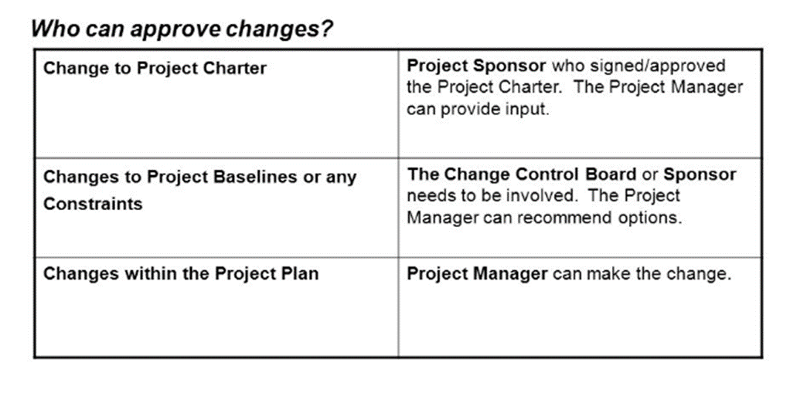A **baseline** is the approved project management plan plus approved changes.
* **Close Project or Phase – Closing :** The process of finalizing all activities for the project, phase, or contract

This process is performed once or at predefined points in the project.-

* **The key benefits of this process are:**
  + The project or phase information is archived,
  + the planned work is completed,
  + and organizational team resources are released to pursue new endeavors
* **Inputs**
* **Project charter**
* **Project management plan:** All components
* **Project documents :**Assumption log**,** Basis of estimates**,** Change log, Issue log , Lessons learned register , Milestone list , Project communications , Quality control measurements , Quality reports , Requirements documentation , Risk register , Risk report**.**
* **Accepted deliverables**
* **Business documents :** Business case ,Benefits management plan
* **Agreements**
* **Procurement documentation**
* **Organizational process assets**
* **Tools & Techniques**
* **Expert judgment**
* **Data analysis :** Document analysis , Regression analysis ,Trend analysis , Variance analysis
* **Meetings**
* **Outputs**
* **Project documents update :** Lessons learned register
* **Final product, service, or result transition**
* **Final report**
* **Organizational process assets updates**
* **Project Scope Management**
* Shows the processes involved in ensuring the project includes all the work required, and only the work required, for completing the project successfully.
* **Product scope.** The features and functions that characterize a product, service, or result.
* **Project scope.** The work performed to deliver a product, service, or result with the specified features and functions. The term “project scope” is sometimes viewed as including product scope.

This includes:

* **Plan Scope Management (Planning):** The process of creating a scope management plan that documents how the project and product scope will be defined, validated, and controlled.
* **Inputs**
* **Project Charter**
* **Project Management Plan :** Quality Management Plan /Project Life Cycle Description /Development Approach
* **Enterprise Environmental Factors :** Organization’s Culture, Infrastructure, Personnel Administration, Marketplace Conditions.
* **Organizational Process Assets :** Policies And Procedures , Historical Information And Lessons Learned Repositories.
* **Tools And Techniques**
* **Expert Judgment :** Previous similar projects , Information in the industry, discipline, and application area.
* **Data Analysis :**Various ways of collecting requirements, elaborating the project and product scope, creating the product, validating the scope, and controlling the scope are evaluated.
* **Meetings :** Project teams may attend project meetings to develop the scope management plan. Attendees may include the project manager, the project sponsor, selected project team members, selected stakeholders, anyone with responsibility for any of the scope management processes, and others as needed.
* **Outputs**
* **SCOPE MANAGEMENT PLAN**
  1. Process for preparing a project scope statement;
  2. Process that enables the creation of the WBS from the detailed project scope statement;
  3. Process that establishes how the scope baseline will be approved and maintained; and
  4. Process that specifies how formal acceptance of the completed project deliverables will be obtained.
  5. The scope management plan can be formal or informal, broadly framed or highly detailed, based on the needs of the project
* **REQUIREMENTS MANAGEMENT PLAN**
* How requirements activities will be planned, tracked, and reported;
* *Configuration management activities* such as: how changes will be initiated; how impacts will be analyzed; how they will be traced, tracked, and reported; as well as the authorization levels required to approve these changes.
* **Collect Requirements (Planning):**The process of determining, documenting, and managing stakeholder needs and requirements to meet project objectives.
* **Inputs**
* **Project Charter**
* **Project Management Plan :** Scope Management Plan / Requirements Management Plan. / Stakeholder Engagement Plan.
* **Project Documents:** Assumption Log / Lessons Learned Register / Stakeholder Register.
* **Agreements**
* **Enterprise Environmental Factors**
* **Organizational Process Assets**
* **Tools And Techniques**
* **Expert Judgment :** Expertise Should Be Considered From Individuals Or Groups With Specialized Knowledge Or Training In The Following Topics: Business Analysis, Requirements Elicitation, Requirements Analysis, Requirements Documentation, Project Requirements In Previous Similar Projects, Diagramming Techniques, Facilitation, And Conflict Management.
* **Data Gathering :** Brainstorming /Interviews /Focus groups / Questionnaires and surveys / Benchmarking.
* **Data Analysis :** Includes different techniques related to document analysis. Document analysis consists of reviewing and assessing any relevant documented information. Examples of documents that can be analyzed: Agreements, business plans, problem/issue logs etc.
* **Decision Making**
  1. **Voting**:
     1. **Unanimity**. A decision that is reached whereby everyone agrees on a single course of action.
     2. **Majority.** A decision that is reached with support obtained from more than 50% of the members of the group.
     3. **Plurality.** A decision that is reached whereby the largest block in a group decides, even if a majority is not achieved. This method is generally used when the number of options nominated is more than two.
  2. **Autocratic decision making**:In this method, one individual takes responsibility for making the decision for the group.
  3. **Multicriteria decision analysis:** A technique that uses a decision matrix to provide a systematic analytical approach for establishing criteria, such as risk levels, uncertainty, and valuation, to evaluate and rank many ideas.
  4. **Data Representation**
     1. **Affinity diagrams.** Affinity diagrams allow large numbers of ideas to be classified into groups for review and analysis.
     2. **Mind mapping.** Mind mapping consolidates ideas created through individual brainstorming sessions into a single map to reflect commonality and differences in understanding and to generate new ideas.
  5. **Interpersonal And Team Skills**
     1. Nominal group technique.
     2. Observation/conversation
     3. Facilitation
  6. **Context Diagram :** is an example of a scope model. Context diagrams visually depict the product scope by showing a business system (process, equipment, computer system, etc.), and how people and other systems.
  7. **Prototypes :** is a method of obtaining early feedback on requirements by providing a model of the expected product before actually building it. Examples of prototypes are small-scale products, computer generated 2D and 3D models, mock-ups, or simulations.
* **OUTPUTS**
* **Requirements Traceability Matrix :**The Requirements Traceability Matrix Is A Grid That Links Product Requirements From Their Origin To The Deliverables That Satisfy Them.

1. Business Needs, Opportunities, Goals, And Objectives;
2. Project Objectives;
3. Project Scope And WBS Deliverables;
4. Product Design;
5. Product Development;
6. Test Strategy And Test Scenarios; And
7. High-Level Requirements To More Detailed Requirements

* **Define Scope (Planning):**The process of developing a detailed description of the project and product.

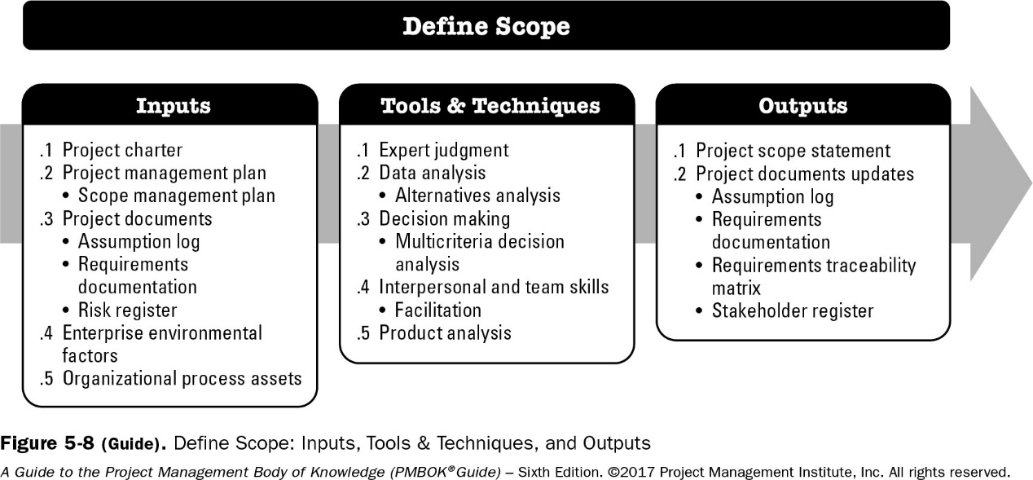

* **Create WBS (Planning):** The process of subdividing project deliverables and project work into smaller, more manageable components

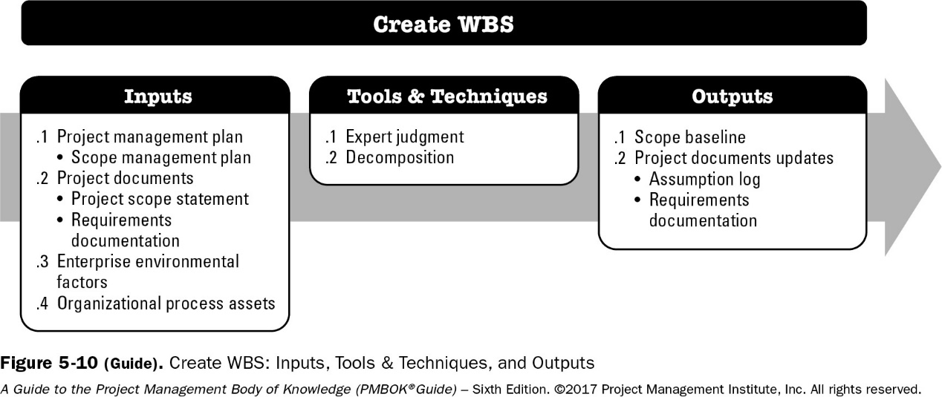

* **Decomposition** : Identifying and analyzing the deliverables and related work, Structuring and organizing the WBS, Decomposing the upper WBS levels into lower-level detailed components, Developing and assigning identification codes to the WBS components, Verifying that the degree of decomposition of the deliverables is appropriate.
* **Scope Baseline**:

**a. Project scope statement**: includes description of the project scope, deliverables, assumptions, and constraints.

**b. WBS**: The hierarchical decomposition of the total scope of work. Each descending level represents a more detailed definition of the project work.

* + **Work package**: This is the lowest level of the WBS. It has a unique identifier. These identifiers provide a structure for hierarchical summation of costs, schedule, and resource information and form a code of accounts.

**c. WBS dictionary**: is a document that provides detailed deliverable, activity, and scheduling information about each component in the WBS. WBS dictionary may include but is not limited to the following:

* **Validate Scope (M&C):** The process of formalizing acceptance of the completed project deliverables.

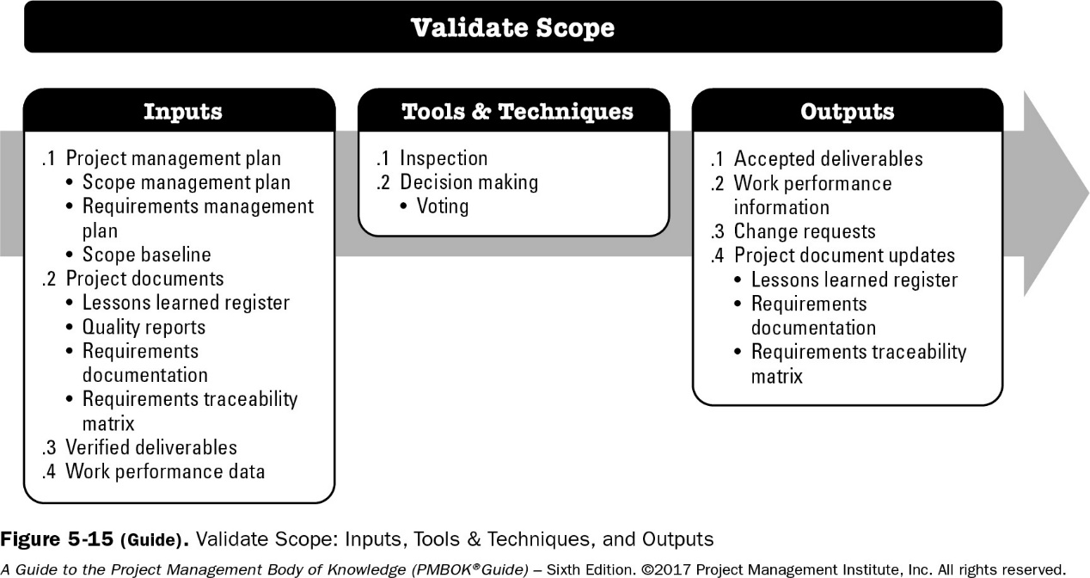

* **Control Scope (M&C)** : The process of monitoring the status of the project and product scope and managing changes to the scope baseline.

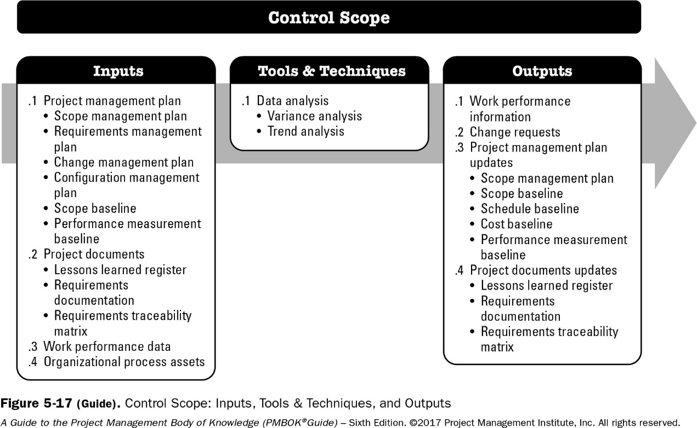

* **Project Schedule Management**
* Focuses on the processes that are used to help ensure the timely completion of the project.
* **Importance of Project Schedules :** Managers often cite delivering projects on time as one of their biggest challenges , Time has the least amount of flexibility; it passes no matter what happens on a project , Schedule issues are the main reason for conflicts on projects, especially during the second half of projects.
* This includes:
* **Plan Schedule Management (Planning):** determining the policies, procedures, and documentation that will be used for planning, executing, and controlling the project schedule.

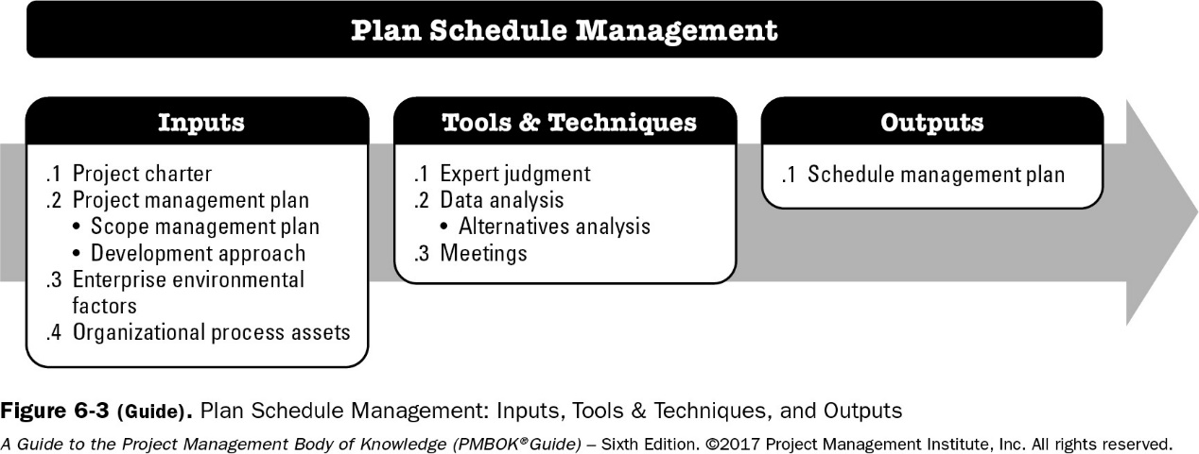

* **Define Activities (Planning):**identifying the specific activities that the project team members and stakeholders must perform to produce the project deliverables.

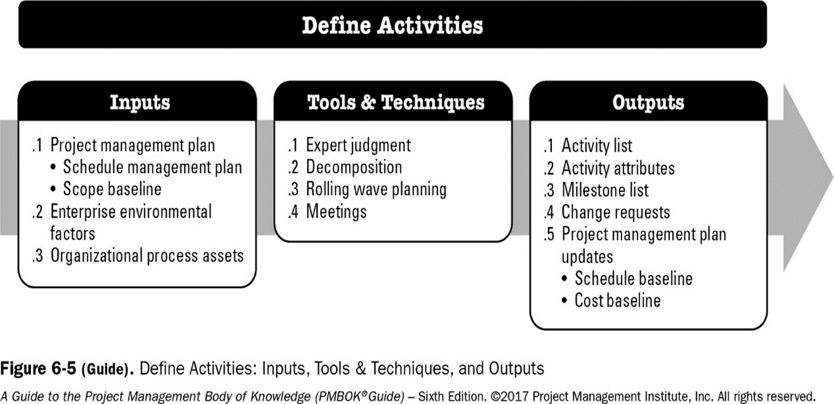

* A. **Activity List** : is a tabulation of activities to be included on a project schedule that includes : (The Activity Name , An Activity Identifier Or Number , A Brief Description Of The Activity).
* b. **Activity Attributes**: provide more information about activities such as predecessors, successors, logical relationships, leads and lags, resource requirements, constraints, imposed dates, and assumptions related to the activity.

1. **Milestone** : is a significant event that normally has no duration.

* **Sequence Activities (Planning):**identifying and documenting the relationships between project activities**.**

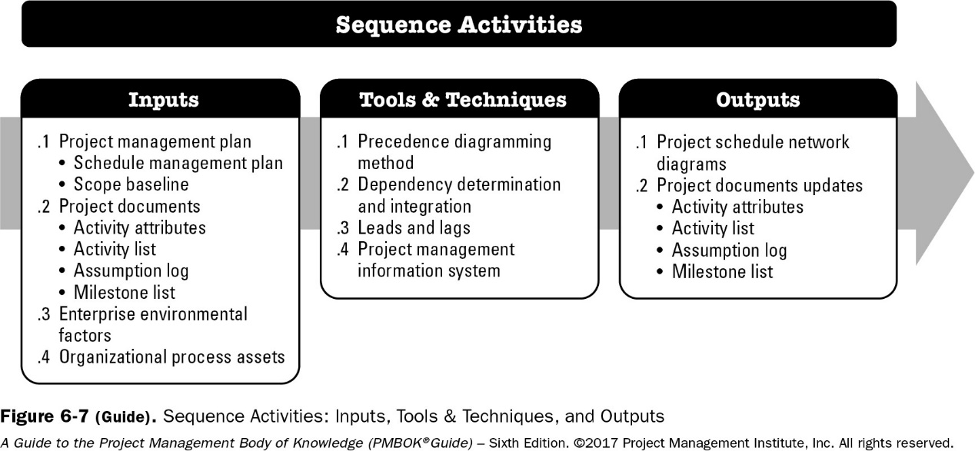

* **Estimate Activity Resources (Planning):**estimating the number of work periods that are needed to complete individual activities**.**
* 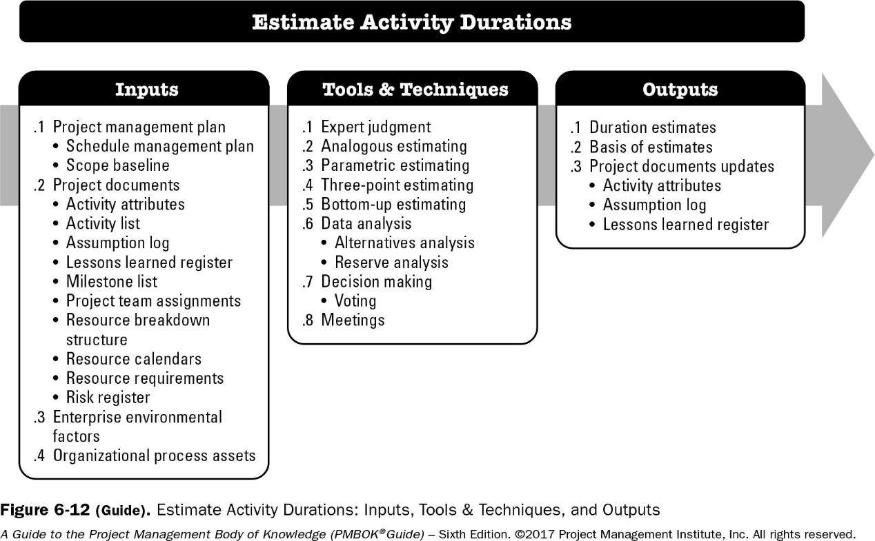**Estimate Activity Durations (Planning):**estimating the number of work periods that are needed to complete individual activities.
* **Develop Schedule (Planning):** analyzing activity sequences, activity resource estimates, and activity duration estimates to create the project schedule.

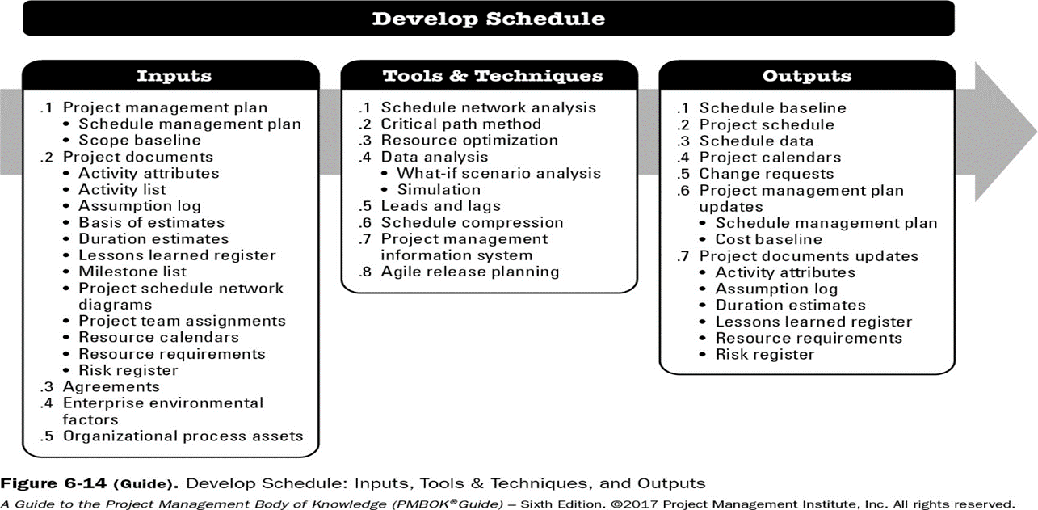

* **Control Schedule (M&C):**controlling and managing changes to the project schedule.

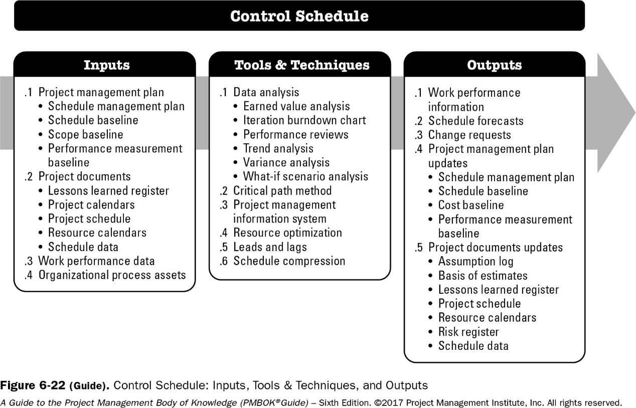

* **Project Cost Management**
* Describes the processes involved in planning, estimating, budgeting, and controlling cost so that the project can be completed within the approved budget. This includes:
* **Plan Cost Management (Planning):** defining how the project costs will be estimated, budgeted, managed, monitored, and controlled. The key benefit of this process is that it provides guidance and direction on how the project costs will be managed throughout the project.

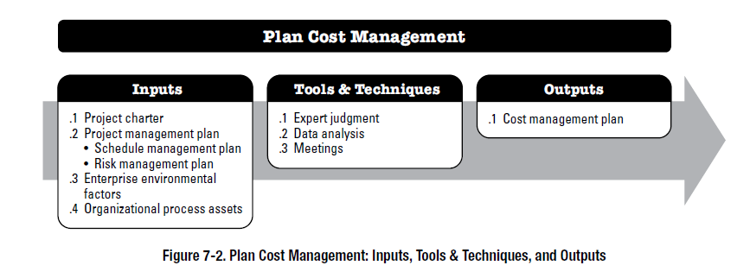

* **Estimate Costs (Planning):** is the process of developing an approximation of the cost of resources needed to complete project work. The key benefit of this process is that it determines the monetary resources required for the project. This process is performed periodically throughout the project as needed.

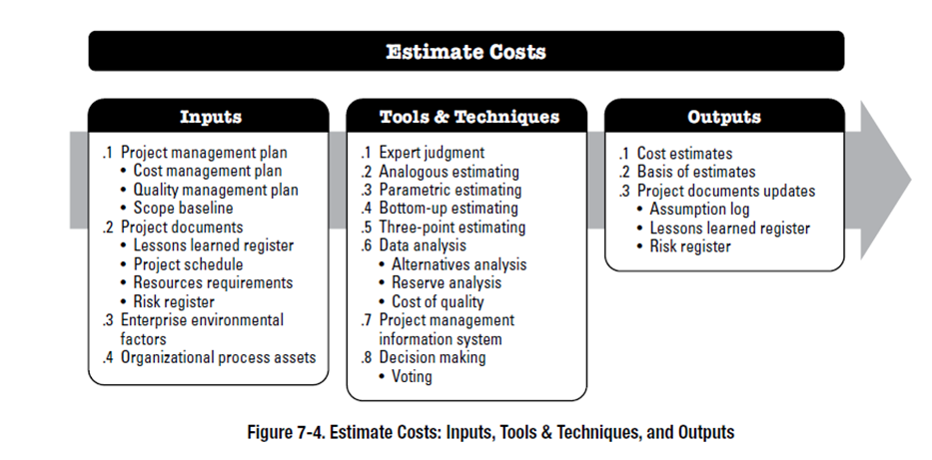

1. **Three-Point Estimating:**The accuracy of single-point cost estimates may be improved by considering estimation uncertainty and risk and using three estimates to define an approximate range for an activity’s cost:

* **Most likely (cM).** The cost of the activity, based on realistic effort assessment for the required work and any predicted expenses.
* **Optimistic (cO).** The cost based on analysis of the best-case scenario for the activity.
* **Pessimistic (cP).** The cost based on analysis of the worst-case scenario for the activity.
* Triangular distribution. cE = (cO + cM + cP) / 3
* Beta distribution. cE = (cO + 4cM + cP) / 6
  1. **Analogous** or **top-down estimates:** use the actual cost of a previous, similar project as the basis for estimating the cost of the current project.
  2. **Bottom-up estimates:** involve estimating individual work items or activities and summing them to get a project total.
  3. **Parametric modeling** uses project characteristics (parameters) in a mathematical model to estimate project costs.
* **Determine Budget (Planning)**

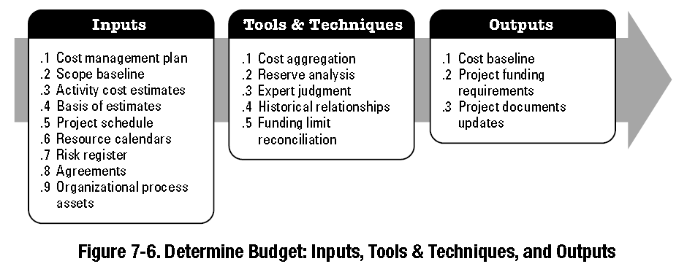

* **Control Costs (M&C)**

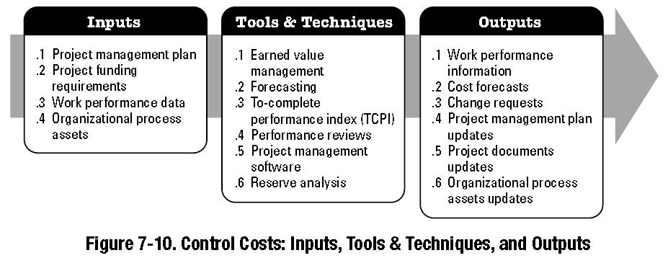

* **Project Quality Management**
* Describes all the processes for incorporating the organization’s quality policy regarding planning, managing, and controlling project and product quality requirements, in order to meet stakeholders’ expectations. This includes:
  + Plan Quality Management (Planning)
  + Manage Quality (Executing)
  + Control Quality (M&C)
* **Project Resource Management**
* Describes the processes involved in the planning, acquisition, development, and management of the project team. This includes:
* **Plan Resource Management (Planning):** The process of tracking team member performance, providing feedback, resolving issues, and managing team changes to optimize project performance
* **Estimate Activity Resources (Planning):**The process of estimating team resources and the type and quantities of material, equipment, and supplies necessary to perform project work. 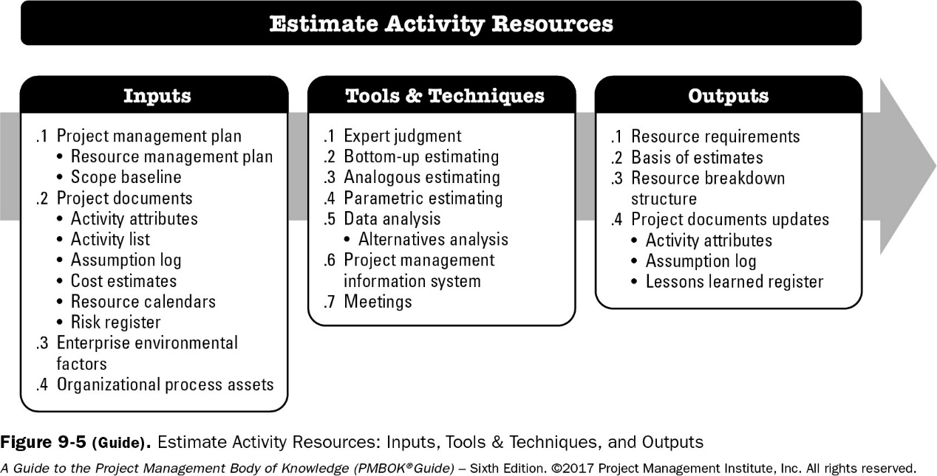
  + **Expert judgment** means getting help from people who have already executed similar projects, or people who have the necessary training to gain the knowledge.
  + **Analogous estimating**: You look at similar activities with similar resource category and types from similar type of projects executed earlier and base your estimates on this information. This method is most useful when you don’t have enough information in the current project and you are doing progressive elaboration. This technique takes lesser time but at the cost of being less accurate. Best fit for this is the case when current project and the team is similar to the previous project and its team.
  + **Parametric estimating**: calculate cost or duration values for activities based on data from similar earlier projects. You put in numbers, or parameters, into a spreadsheet or software that uses data from other similar past projects to calculate estimates. Parametric estimating method gives more accurate results than analogous estimating technique provides.
  + 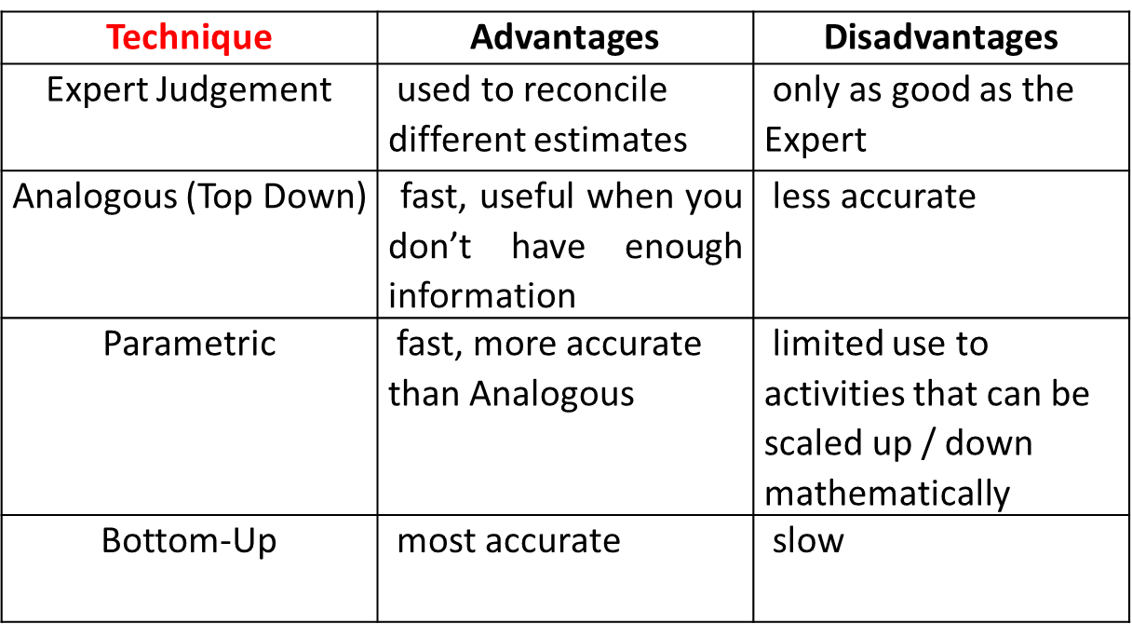**Bottom-up estimating**. This is pretty simple – you break down activity into smaller pieces, to the level where estimating resources is easy. Then you roll up the estimates to the level of original activity. This will be your resource estimate for the activity.
* **Acquire Resources (Executing):** The process of obtaining team members, facilities, equipment, materials, supplies, and other resources necessary to complete project work.
* **Develop Team (Executing):** The process of improving competencies, team member interaction, and the overall team environment to enhance project performance.
* **Manage Team (Executing)** The process of tracking team member performance, providing feedback, resolving issues, and managing team changes to optimize project performance
* **Control Resources (M&C) :** The process of tracking team member performance, providing feedback, resolving issues, and managing team changes to optimize project performance.
* **Project Communications Management**
* Identifies the processes involved in ensuring timely and appropriate generation, collection, dissemination, storage, and ultimate disposition of project information.
* Communication activities have many dimensions, this includes:
* **Internal**: Focus on stakeholders within the project and within the organization.
* **External**: Focus on external stakeholders such as customers, vendors, government, and the public.
* **Formal**: Reports, formal meetings, meeting agendas and minutes.
* **Informal**: General communications activities using emails, social media, websites, and informal discussions.
* **Official**: Annual reports; reports to regulators or government bodies.
* **Unofficial**: Communications that focus on establishing and maintaining the profile and recognition of the project and building strong relationships between the project team and its stakeholders using informal means.
* **Written and oral**: Verbal (words and voice inflections) and nonverbal (body language and actions), social media, websites, and media releases.
* Skills :
* Listening actively.
* Awareness of cultural and personal differences.
* Identifying, setting, and managing stakeholder expectations.

This includes:

* **Plan Communications Management (Planning)** : information needs of each stakeholder, a documented approach to effectively and efficiently engage stakeholders, performed periodically throughout the project as needed.
  + **Communication Methods :** 
    - (Interactive communication): Between two or more parties performing a multidirectional exchange of information in real time.
    - (Push communication.): Sent or distributed directly to specific recipients who need to receive the information.
    - (Pull communication): Used for large complex information sets, or for large audiences, and requires the recipients to access content at their own discretion subject to security procedures

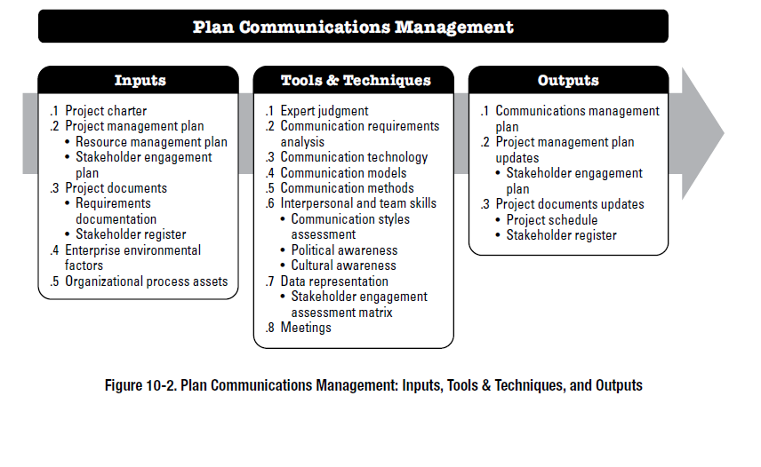

* 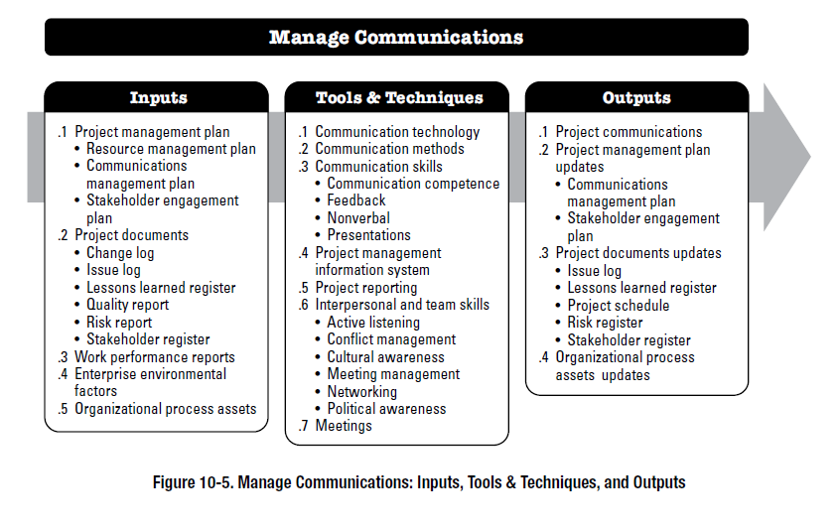**Manage Communications (Executing) : of** ensuring timely and appropriate collection, creation, distribution, storage, retrieval, management, monitoring, and the ultimate disposition of project information, is enabling an efficient and effective information flow between the project team and the stakeholders
* **Monitor Communications (M&C):** ensuring the information needs of the project and its stakeholders are met, is the optimal information flow as defined in the communications management.

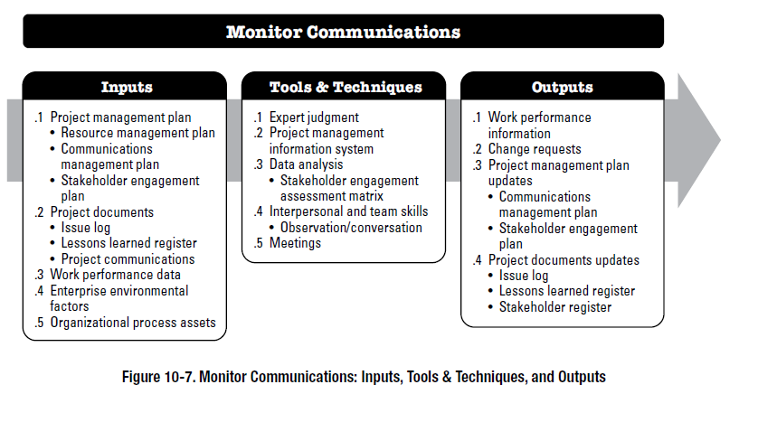

* **Project Risk Management**
* Describes the processes involved with identifying, analyzing, and controlling risks for the project. This includes:
* **Plan Risk Management (Planning):** is the process of defining how to conduct risk management activities for a project.The key benefit of this process is that it ensures that the degree, type, and visibility of risk management are proportionate to both risks and the importance of the project to the organization and other stakeholders.

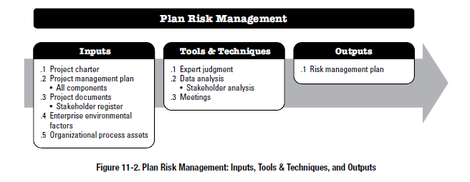

* **Identify Risks (Planning):**understanding what potential events might hurt or enhance a particular project

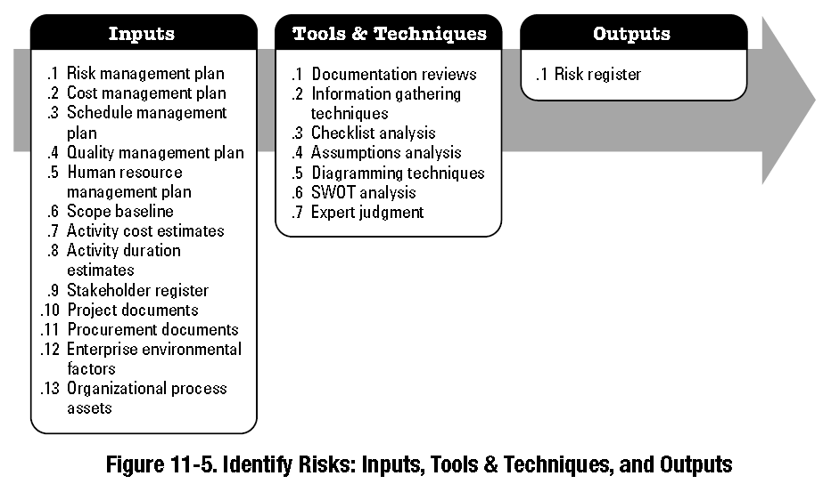

* **Perform Qualitative Risk Analysis (Planning):**The process of prioritizing risks for further analysis or action by assessing and combining their probability of occurrence and impact.

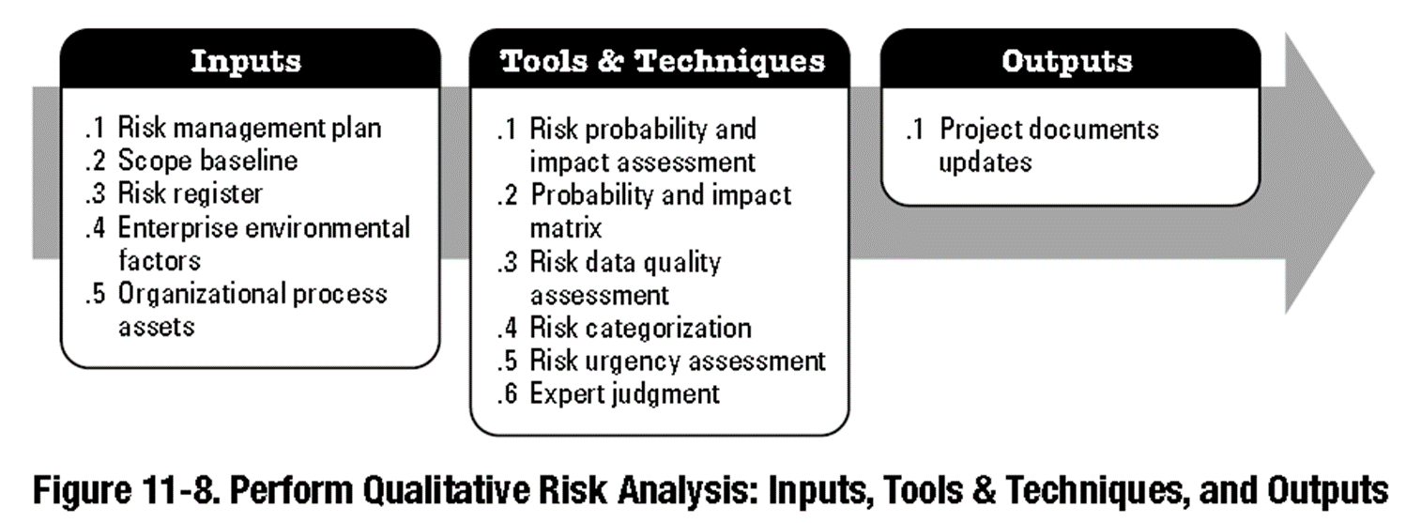

* **Perform Quantitative Risk Analysis (Planning):**The process of numerically analyzing the effect of identified risks on overall project objectives

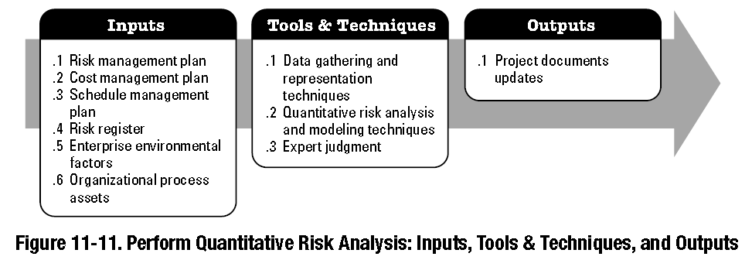

* **Plan Risk Responses (Planning):**The process of developing options and actions to enhance opportunities and to reduce threats to project objectives.The key benefit is to address the risks by their priority, have strategies to handle the risks and assigned resources & budget to handle those risks.

|  |  |
| --- | --- |
| **Strategies for negative risks:**   * Avoid * Transfer * Mitigate * Accept | **Strategies for positive risks:**   * Exploit * Share * Enhance * Accept |

**General Risk Mitigation Strategies for Technical, Cost, and Schedule Risks**

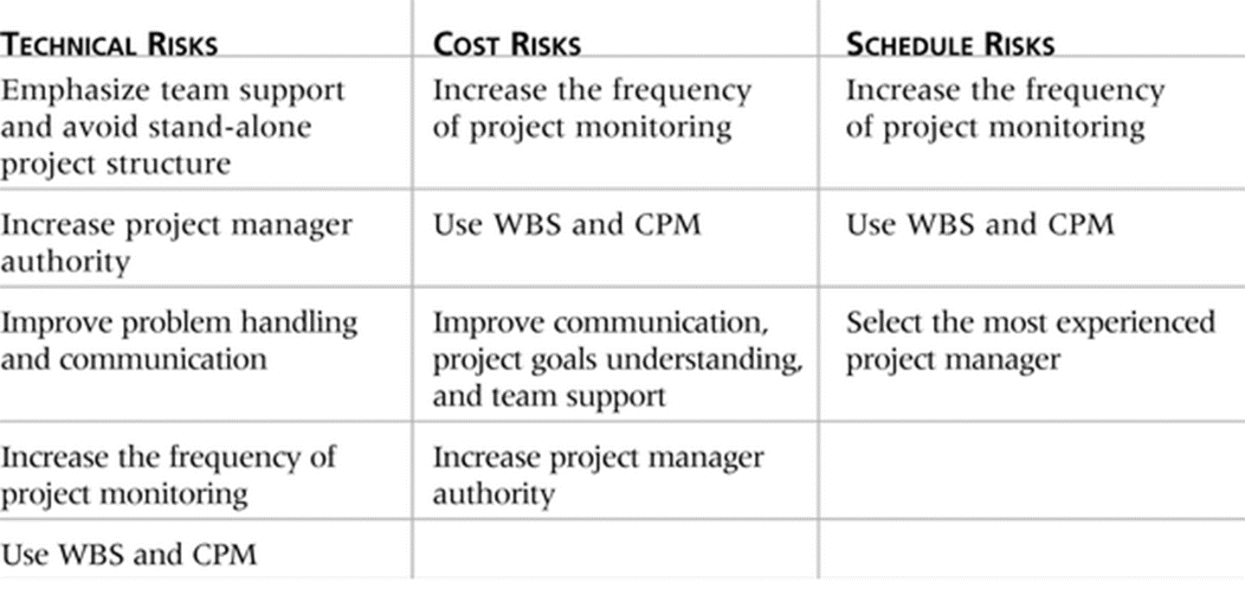

* **Implement Risk Responses (Executing)**
* **Monitor & Control Risk (M&C)**

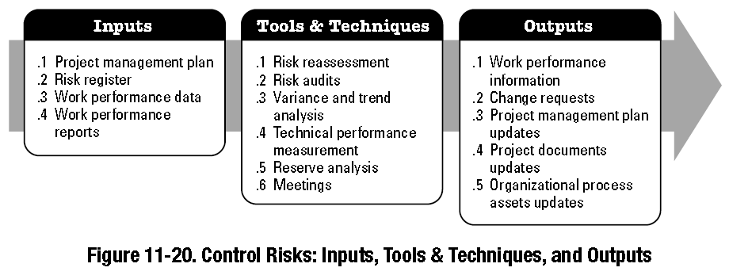

* **Project Procurement Management**
* Describes the processes involved with purchasing or acquiring product, services, or results for project. This includes:
* Plan Procurement Management (Planning)
* Conduct Procurements (Executing)
* Control Procurements (M&C)
* **Project Stakeholder Management**
* Describes the processes involved with managing the stakeholders for the project. This includes:
* **Identify Stakeholders (Initiating)**

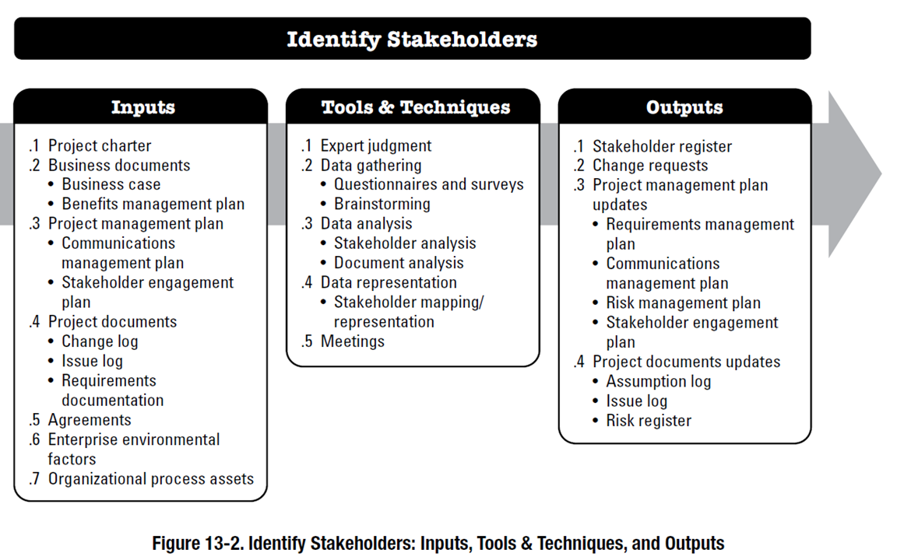

* **Plan Stakeholder Management (Planning):** a focus on continuous communication with all stakeholders, including team members , their needs and expectations , project manager to increase support and minimize resistance from stakeholders.

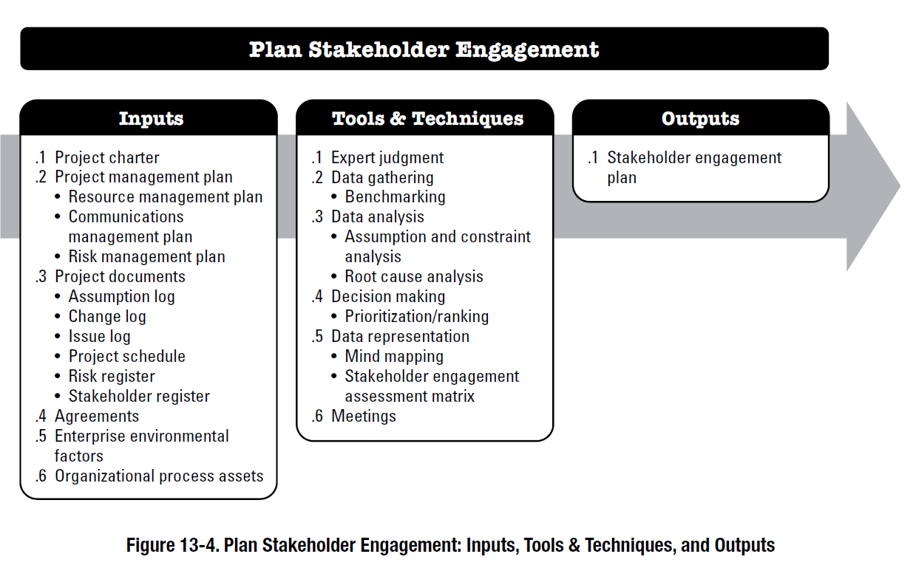

* 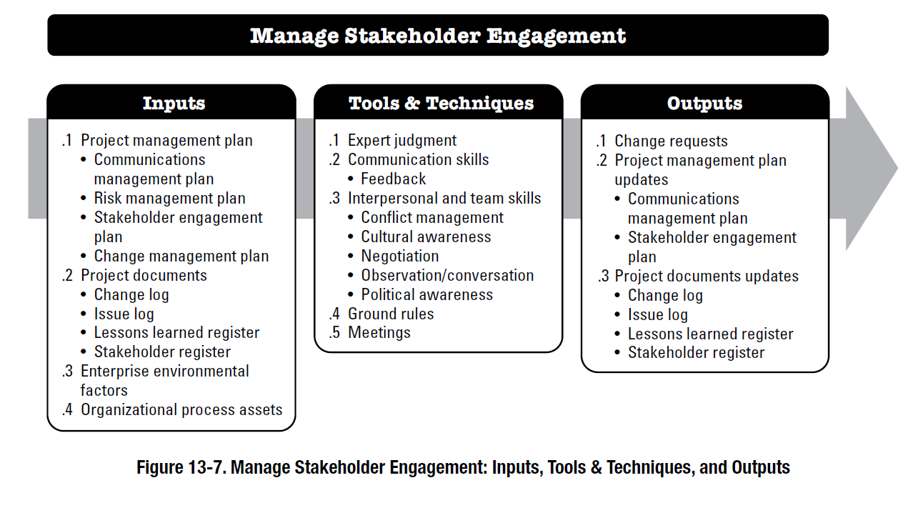**Manage Stakeholder Engagement (Executing): is to maintain the efficiency and effectiveness of stakeholder engagement activities as the project evolves and its environment changes.**
* 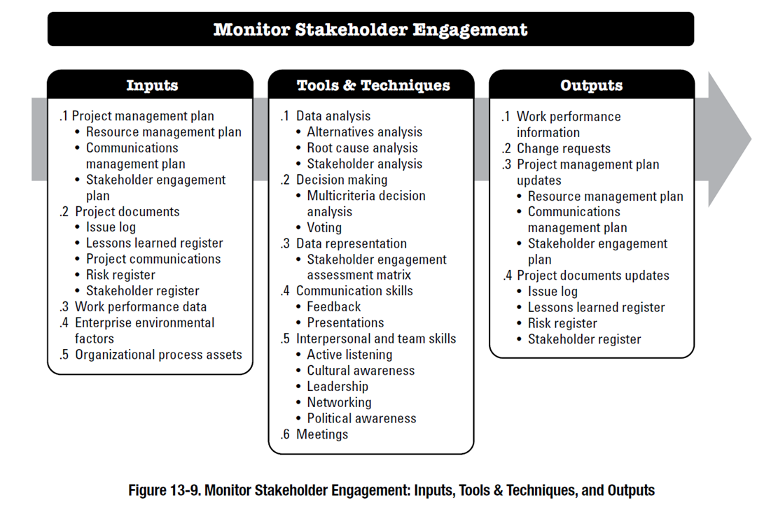**Monitor Stakeholder Engagement(M&C)**

**GROUPINGS OF TOOLS AND TECHNIQUES**

1. **Data gathering techniques.** Used to collect data and information from a variety of sources.
   * + Brainstorming
     + Interviews
     + Focus Groups
2. **Data analysis techniques.** Used to organize, assess, and evaluate data and information.
   * + Document Analysis
     + Assumption and Constraint Analysis
     + Earned Value Analysis
     + Stakeholder Analysis
3. **Data representation techniques.** Used to show graphic representations or other methods used to convey data and information.
   * + Histograms
     + Flowcharts
     + Cause-and-effect diagrams
4. **Decision-making techniques.** Used to select a course of action from different alternatives.
   * + Voting
5. **Communication skills.** Used to transfer information between stakeholders.
   * + Feedback
     + Presentations
6. **Interpersonal and team skills.** Used to effectively lead and interact with team members and other stakeholders.
7. **Ungrouped techniques:** There are 60 ungrouped tools and techniques.
   * + Critical Path Method

* **Tailoring**
  + Project managers apply a project management framework to their work. All 49 processes are not always used.
  + The appropriate project management processes, inputs, tools, techniques, outputs, and life cycle phases should be selected to manage a project, based on project requirements, resources available and capabilities of the organization
  + This selection activity is known as tailoring project management to the project.
  + The project manager collaborates with the project team, sponsor, organizational management, or a combination of these people in the tailoring.

**Project Environments**

* 1. **Enterprise Environmental Factors:** These are factors that influence, constrain, or direct the project, program, or portfolio. , These factors are not under the immediate control of the project manager or the team, For example:
     + Political Decisions
     + Financial Market Changes
     + Disruptions caused by weather
     + Government/Legal policies
     + **EEFS INTERNAL TO THE ORGANIZATION**
     + Organizational culture, structure, and governance
     + Geographic distribution of facilities and resources
     + Infrastructure
     + Information technology software
     + Resource availability
     + Employee capability
  2. **Organizational process assets (OPAs)** are the plans, processes, policies, procedures, and knowledge bases specific to and used by the performing organization.

OPAs include any artifact, practice, or knowledge from any or all of the performing organizations involved in the project that can be used to execute or govern the project. Includes:

* + - Charters of current and previous projects
    - Completed schedules
    - Risk Data
    - Data relating to purchase of materials for projects
    - Lessons learnt on projects
* OPAs Grouped into two categories:

1. Processes, policies, and procedures
   * Not updated as part of the project work.
   * Processes, policies, and procedures are usually established by the project management office (PMO) or another function outside of the project.
2. Organizational knowledge bases
   * Updated throughout the project with project information.
   * **For example,** information on financial performance, lessons learned, performance metrics and issues

* **EVA** is a project performance measurement technique that integrates scope, time, and cost data.

**Earned Value Terms**:

* + - The **planned value (PV),** is that portion of the approved total cost estimate planned to be spent on an activity during a given period.
    - **Actual cost (AC),** is the total of direct and indirect costs incurred in accomplishing work on an activity during a given period.
    - The **earned value (EV),** is an estimate of the value of the physical work actually completed.
* **Rate of performance (RP)** is the ratio of actual work completed to the percentage of work planned to have been completed at any given time during the life of the project or activity.

Formula Sheet

PV= BAC * (% of estimated completion at the current assessment time) = BAC * current time/total time

EV= BAC * (% of actual completed task)

CV = EV – AC

CV < 0 OVER BUDGET

CV = 0 EXACTLY ON BUDGET

CV >0 UNDER BUDGET (GOOD THING)

SV = EV – PV

VAC = BAC – EAC

CPI = EV/AC

CPI <1 OVER BUDGET

CPI =0 ON BUDGET (GOOD)

CPI >1 UNDER BUDGET (GOOD)

SPI = EV/PV

SPI <1 BEHIND OF SCHEDUAL

SPI =0 ON SCHEDUAL

SPI >1 AHEAD OF SCHEDUAL

EAC = BAC/CPI

ETC = EAC – AC

TCPI = (BAC-EV)/(BAC-AC)

RP= (% of actual completion at the current assessment time/percentage of work planned to have been completed)

EV = PV *RP

**Develop the budget for the project**

|  |  |  |  |  |
| --- | --- | --- | --- | --- |
| **Item** | **Units** | **Cost** | **Total** | **% of total** |

Total: Unit * Cost= Total

reverse :Totals * Reverse%

% of total:Total/ Total estimate*100

How to find Total estimate: Totals + Reserve total